|  |  |  |
| --- | --- | --- |
| NAME | REGISTRATION NO. | ROLL NO. |
| BIKIRAN BORAH | 12111199 | RK21WYA26 |
| VISHAL KUMAR SINGH | 12104228 | RK21WYA01 |

SUBMITTED BY :-

FINAL SUBMISSION REPORT

FOR PYTHON GROUP PROJECT.

"**School of Computer Science & Engineering”**

COURSE CODE :- INT 213



PROJECT:-Design a System for booking Cabs within LPU using python.

**TABLE OF CONTENTS**

* **INTRODUCTION**
* **MAIN OBJECTIVE**
* **WORKFLOW/DESIGN**
* **ALGORITHM**
* **RESULT SCREENSHOTS**
* **CONCLUSION**
* **REFERENCE**
* **ANNEXURE A- CODE OF PROJECT**

**ABOUT PROJECT** -

Cab Booking system is an application which is used for Booking cabs using a computerised software . In this application we can perform many operations like storing CabMs account of every student in university, for available cabs, for available routes, car pool options , charges for particular route, maximum time to reach destination, drivers contact details.   
This application helps everyone in lpu to book the transport for their destination from lpu only in the best possible way.

**PRE SUBMISSION OBJECTIVES:-**

1. To develop a system that can replace the manual transport booking system.
2. Develop a database which stores user details and staff details.
3. User friendly booking procedure.
4. Location tracking and user friendly interface.
5. Arrival time estimation and fare precision.

To make travelling easier and to ride safely and securely.

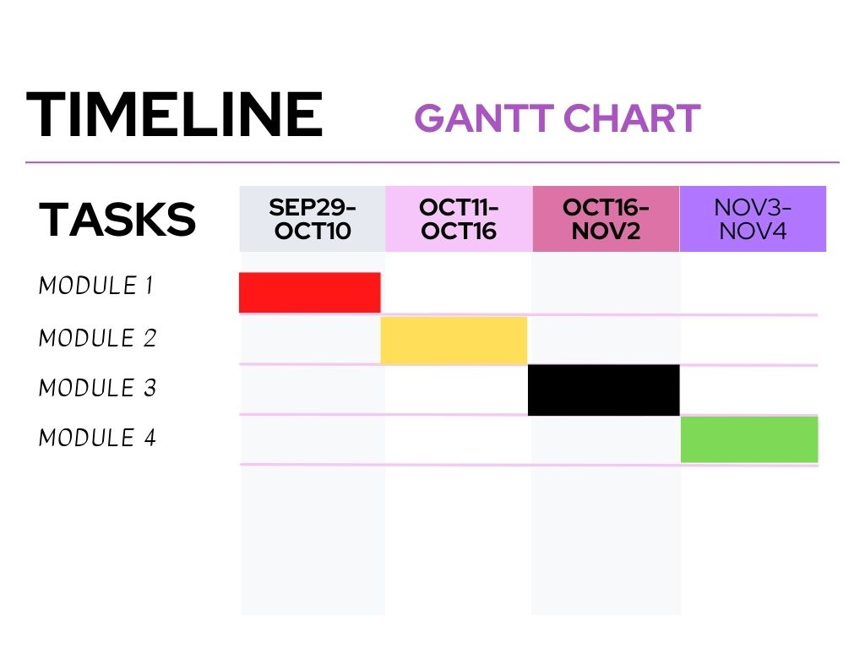

***SUBMISSION***

**Introduction :**

Online Cab Booking System specializing in Hiring cabs to customers. It is an online system through which customers can view available cabs; register the cabs, view profile and book cabs.Cab booking service is a major transport service provided by the various transport operators in a particular city. Mostly peoples use cab service for their daily transportations need. The company must be a registered and fulfils all the requirements and security standards set by the transport department. Online Cab Booking System is a web based platform that allows your customers to book their taxi's and executive taxis all online from the comfort of their own home or office. The platform should offer an administration interface where the taxi company can manage the content, and access all bookings and customer information. More and more Taxi companies are looking for integrated taxi booking systems as it makes life much easier for (1) The traveler - this is highly important and in today's internet age people should be able to book taxis online without having to pick up the phone and (2) the taxi company as all their bookings are now managed via an automated system which means they have an electronic record of future and historic bookings A Cab Booking/Hiring is a system that can be used temporarily for a period of time with a fee. Hiring a car assists people to get around even when they do not have access to their own personal vehicle or don't own a vehicle at all. The individual who want to hire/rent a car must first contact the cab hiring company for the desire vehicle. This can be done online. At this point, this person has to supply some information such as: dates of rental, and type of car. After these details are worked out, the individual renting the car must present a valid Identification Card. Most companies throughout the industry make a profit based of the type of cars.

**MAIN OBJECTIVE :-** Online Cab Booking System specializing in Hiring cabs to customers. It is an online system through which customers can view available cabs; register the cabs, view profile and book cabs. Cab booking service is a major transport service provided by the various transport operators in a particular city. Mostly peoples use cab service for their daily transportations need. The company must be a registered and fulfils all the requirements and security standards set by the transport department. Online Cab Booking System is a web based platform that allows your customers to book their taxi's and executive taxis all online from the comfort of their own home or office. The platform should offer an administration interface where the taxi company can manage the content, and access all bookings and customer information. More and more Taxi companies are looking for integrated taxi booking systems as it makes life much easier for (1) The traveller - this is highly important and in today's internet age people should be able to book taxis online without having to pick up the phone and (2) the taxi company as all their bookings are now managed via an automated system which means they have an electronic record of future and historic bookings A Cab Booking/Hiring is a system that can be used temporarily for a period of time with a fee. Hiring a car assists people to get around even when they do not have access to their own personal vehicle or don't own a vehicle at all. The individual who want to hire/rent a car must first contact the cab hiring company for the desire vehicle. This can be done online. At this point, this person has to supply some information such as: dates of rental, and type of car. After these details are worked out, the individual renting the car must present a valid OBJECTIVES {Online cab Booking System.Most companies throughout the industry make a profit based of the type of cars.

**WORKFLOW/DESIGN FOR THE PROJECT:-**

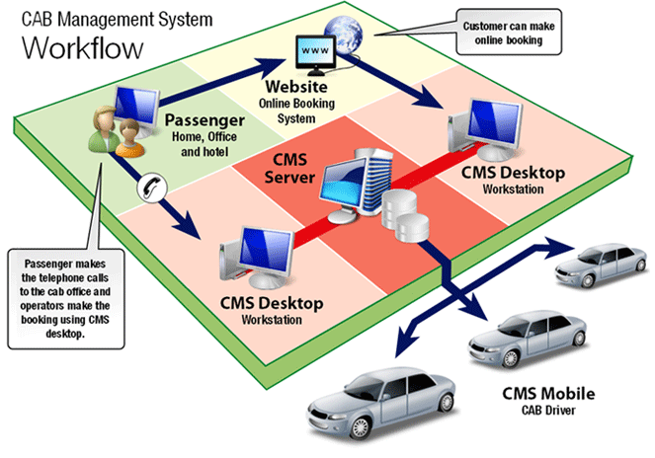

**DFD:-**

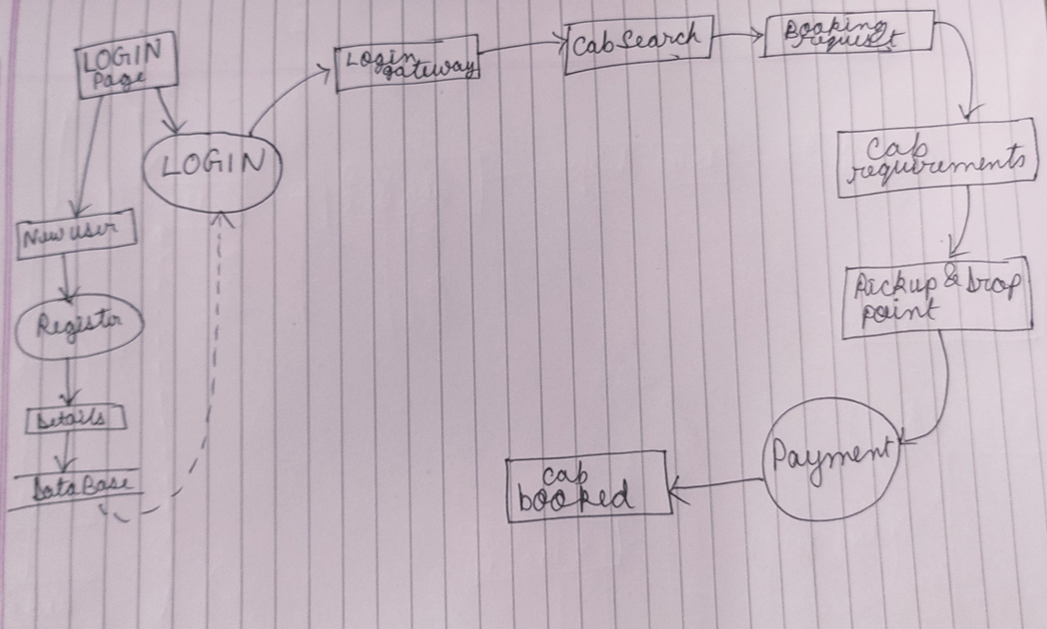

**#DESCRIPTION OF MODULES –**

1) **CABMS ACCOUNT** – It is the cab booking system account of the students and faculties.

2) **REGISTER NEW ACCOUNT**-This module helps in creating account for new users.

3) **BEST ROUTE**- This module helps in finding the best route for the driver.

4) **LOGIN PAGE -** This module helps in login the account.

5) **FARE PRECISION -**This module helps to view and calculate the fare of user.

6) **AVAILABILTY OF CABS-** This module helps to check the available cabs .

7) **BOOKING REQUEST-** This module helps in booking the cab.

8) **CONTACT DETAILS-** This module helps to give contact details of the driver.

9) **FEEDBACK / COMPLAIN-** This module helps to give the feedback to the user. Issues and complaints can also be raised in this module .

**#ALGORITHM:-** Cab Finder Algorithm is used to locate the nearest and safest cab for passengers using specific designed algorithm. This algorithm is designed to give most safe riding suggestions of all the cabs available in the vicinity.

**WORKING:-**

1. The co-ordinates of the taxis are stored regularly on to the server . Thus , in JSON format we have the details of the taxi (details like gps co-odinates of the taxi , rating of taxi driver and trip details)
2. That data is processed to make to find the distances of taxis from the current position of the customer using the formula of co-ordinate distance algorithm.
3. After getting the distances of taxis , other details are taken into account like Rating of the driver ,Number of rides the person has got in that day ,gender of the customer booking the taxi .
4. Then the algorithm is used to calculate total cost for different taxis available.

**#CONCLUSION:-** Thus we conclude our project in which we learnt about GUI and its various functions through which we can make various projects like Capstone portal, scientific calculator , etc in future .

**#RESULT SCREENSHOTS:-**

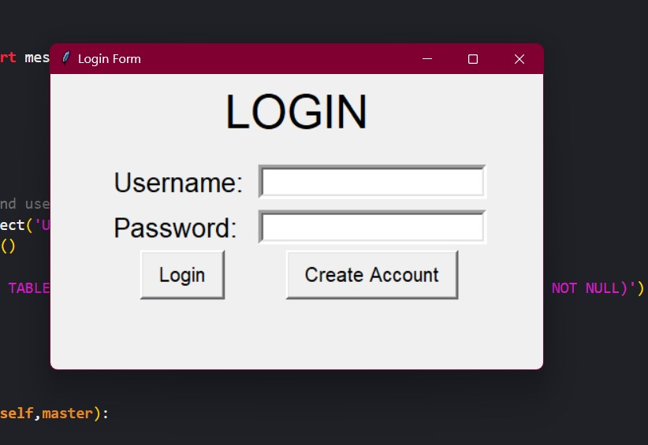

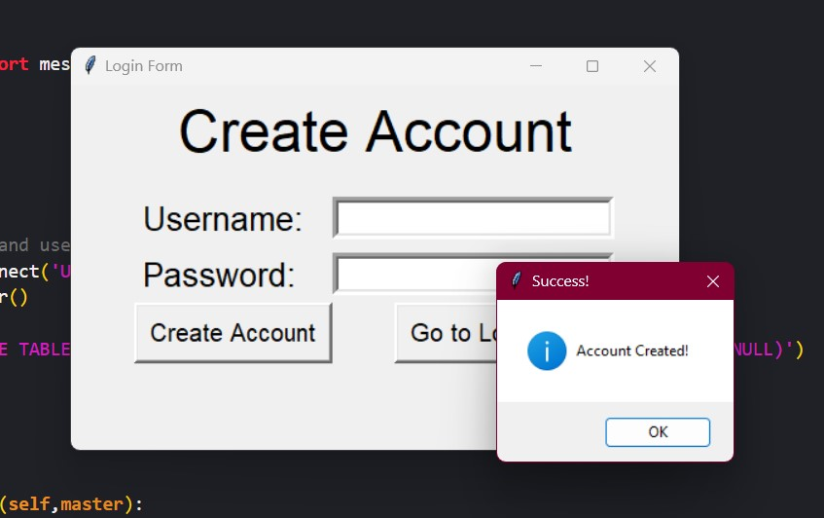

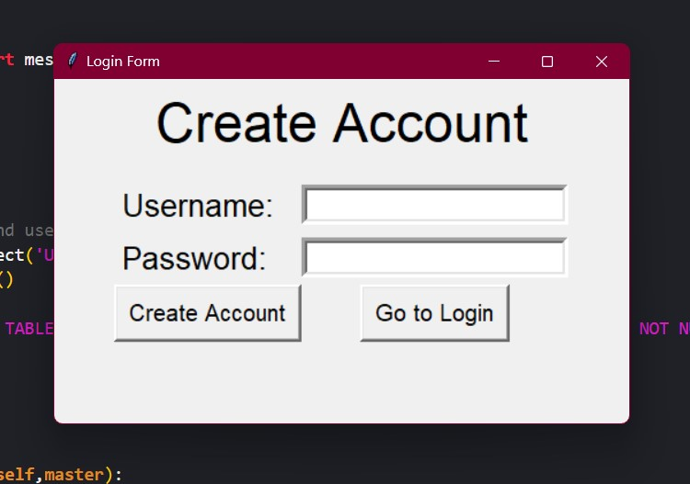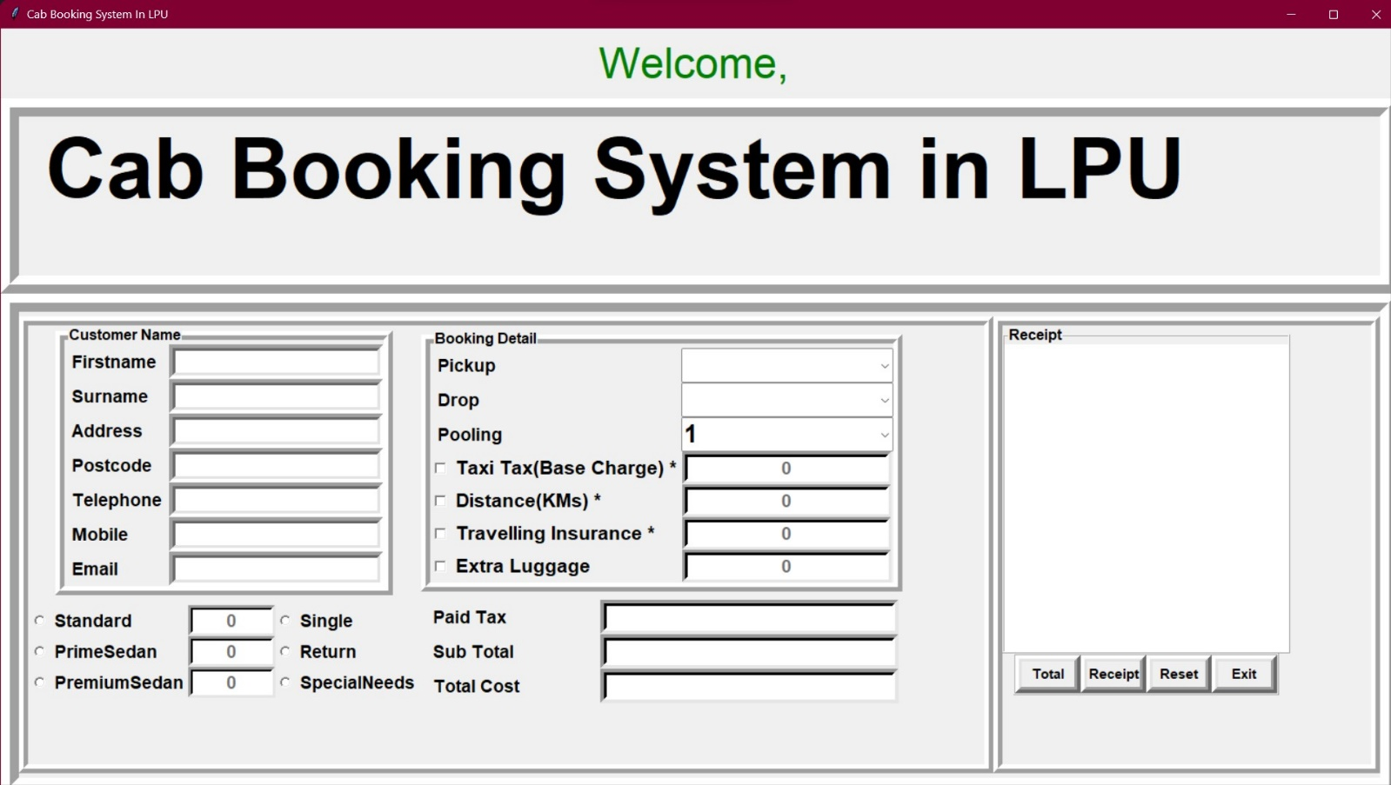

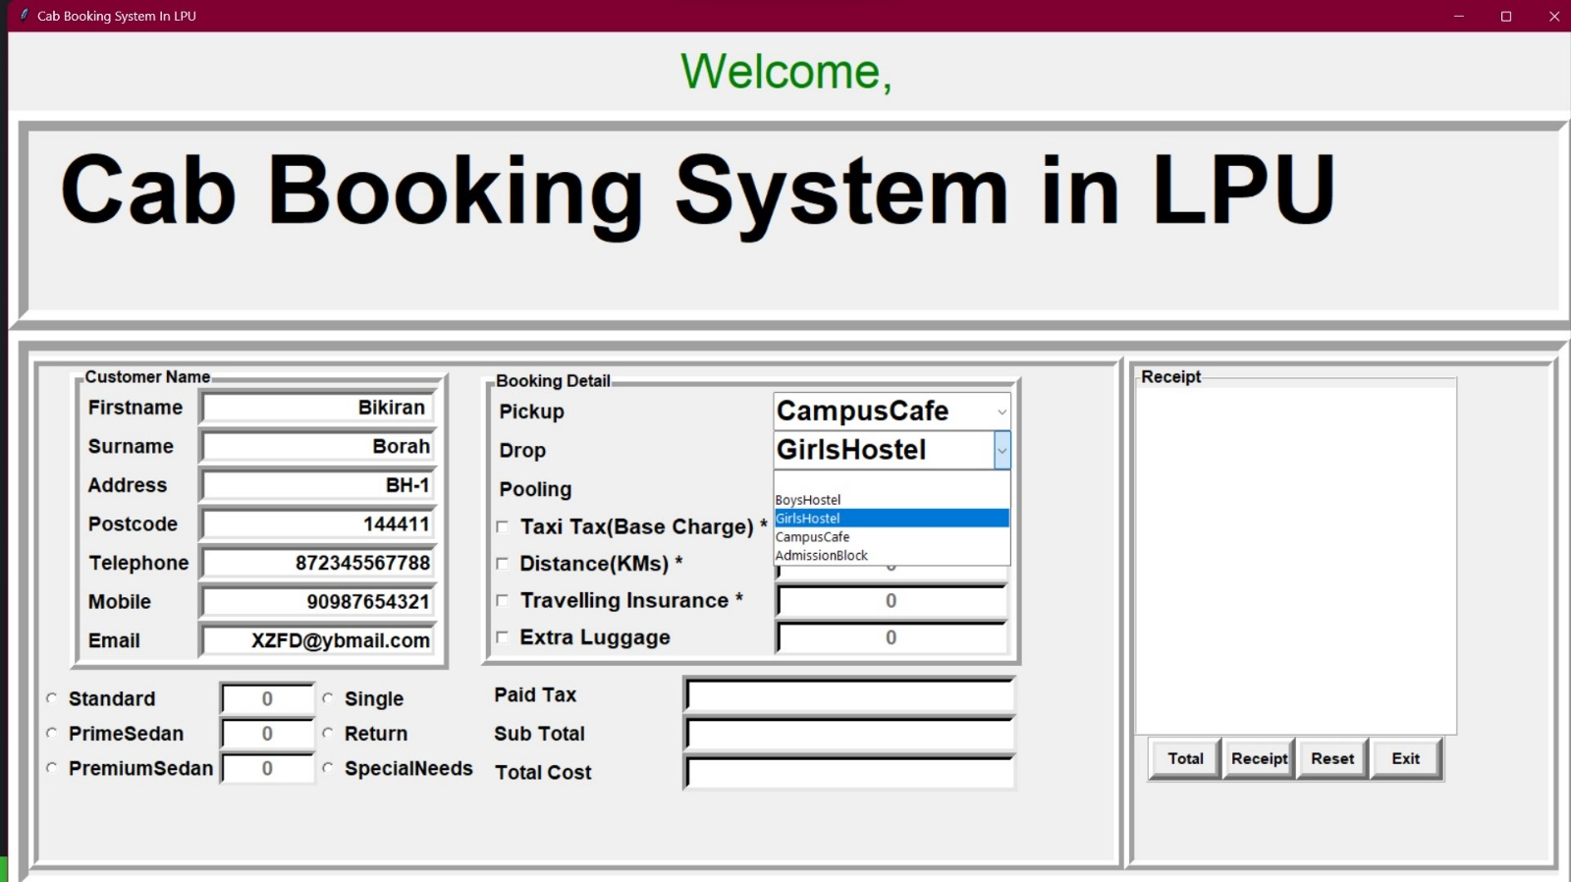

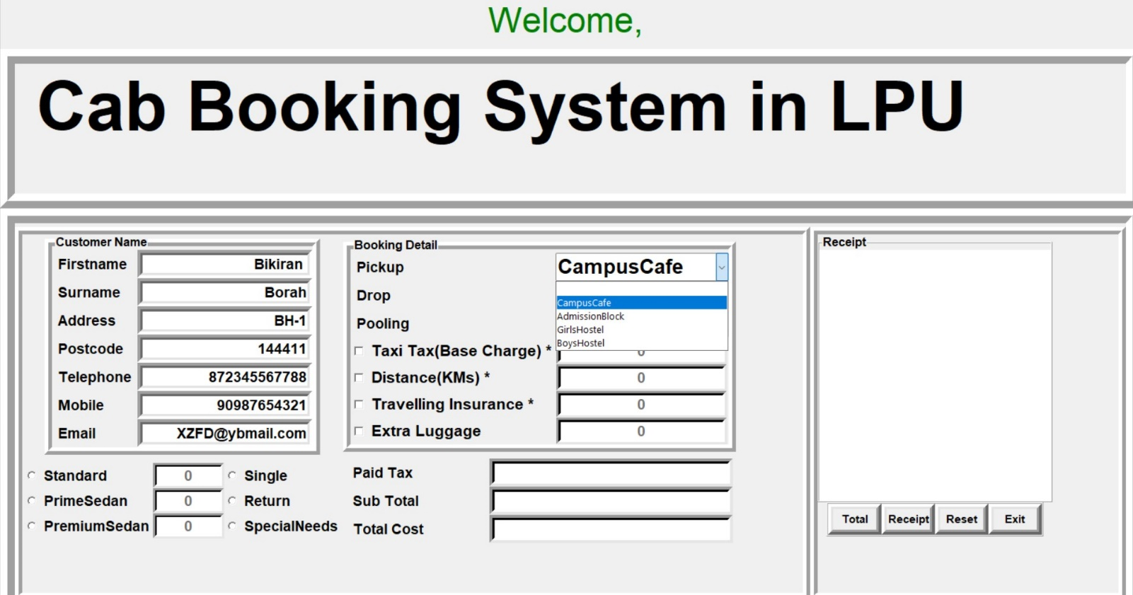

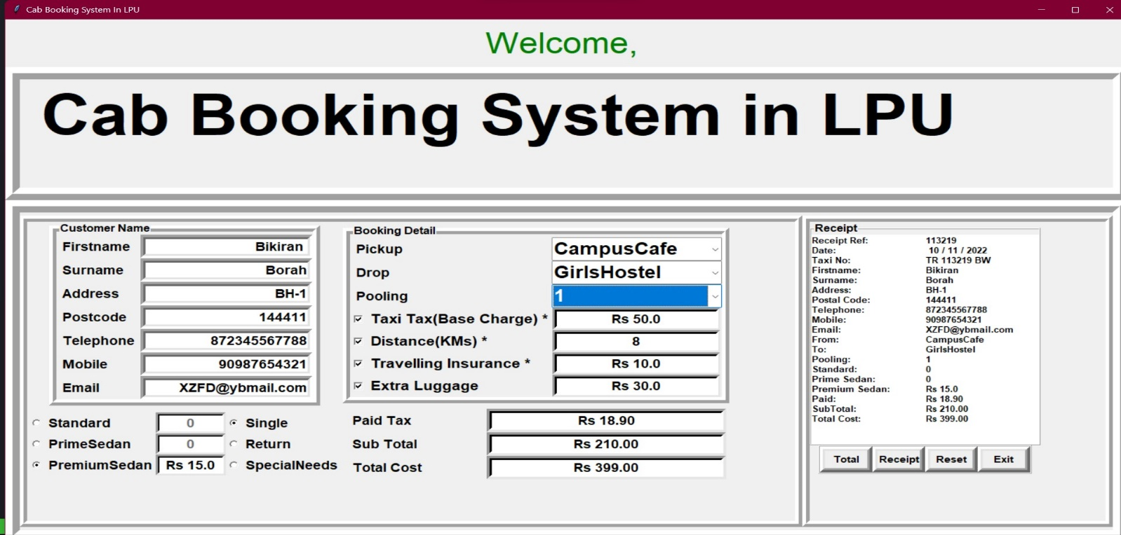

**REFERENCES: -**

Python GUI – tkinter – GeeksforGeeks

tkinter- Python interface to Tcl/Tk – Python 3.11.0 documentation.

**ANNEXURE A- CODE OF THE PROJECT**

**from** tkinter **import** **\***

**from** tkinter **import** ttk

**import** random

**import** time

**import** datetime

**from** tkinter **import** messagebox **as** ms

**import** sqlite3

Item4 **=** 0

# make database and users (if not exists already) table at programme start up

**with** sqlite3.connect('Users.db') **as** db:

    c **=** db.cursor()

c.execute(

    'CREATE TABLE IF NOT EXISTS user (username TEXT NOT NULL ,password TEXT NOT NULL)')

db.commit()

db.close()

# main Class

**class** user:

**def** **__init__**(**self**, **master**):

        # Window

        self.master **=** master

        # Some Usefull variables

        self.username **=** StringVar()

        self.password **=** StringVar()

        self.n_username **=** StringVar()

        self.n_password **=** StringVar()

        # Create Widgets

        self.widgets()

    # Login Function

**def** **login**(**self**):

        # Establish Connection

**with** sqlite3.connect('Users.db') **as** db:

            c **=** db.cursor()

        # Find user If there is any take proper action

        find_user **=** ('SELECT * FROM user WHERE username = ? and password = ?')

        c.execute(find_user, [(self.username.get()), (self.password.get())])

        result **=** c.fetchall()

**if** result:

            self.logf.pack_forget()

            self.head['text'] **=** "Welcome, " **+** self.username.get()

            self.head.configure(**fg=**"green")

            self.head.pack(**fill=**X)

            application **=** travel(root)

**else**:

            ms.showerror('Oops!', 'Username Not Found.')

**def** **new_user**(**self**):

        # Establish Connection

**with** sqlite3.connect('Users.db') **as** db:

            c **=** db.cursor()

        # Find Existing username if any take proper action

        find_user **=** ('SELECT * FROM user WHERE username = ?')

        c.execute(find_user, [(self.username.get())])

**if** c.fetchall():

            ms.showerror('Error!', 'Username Already Taken!')

**else**:

            ms.showinfo('Success!', 'Account Created!')

            self.log()

        # Create New Account

        insert **=** 'INSERT INTO user(username,password) VALUES(?,?)'

        c.execute(insert, [(self.n_username.get()), (self.n_password.get())])

        db.commit()

        # Frame Packing Methords

**def** **log**(**self**):

        self.username.set('')

        self.password.set('')

        self.crf.pack_forget()

        self.head['text'] **=** 'LOGIN'

        self.logf.pack()

**def** **cr**(**self**):

        self.n_username.set('')

        self.n_password.set('')

        self.logf.pack_forget()

        self.head['text'] **=** 'Create Account'

        self.crf.pack()

    # Draw Widgets

**def** **widgets**(**self**):

        self.head **=** Label(self.master, **text=**'LOGIN', **font=**('', 35), **pady=**10)

        self.head.pack()

        self.logf **=** Frame(self.master, **padx=**10, **pady=**10)

        Label(self.logf, **text=**'Username: ', **font=**(

            '', 20), **pady=**5, **padx=**5).grid(**sticky=**W)

        Entry(self.logf, **textvariable=**self.username,

**bd=**5, **font=**('', 15)).grid(**row=**0, **column=**1)

        Label(self.logf, **text=**'Password: ', **font=**(

            '', 20), **pady=**5, **padx=**5).grid(**sticky=**W)

        Entry(self.logf, **textvariable=**self.password, **bd=**5,

**font=**('', 15), **show=**'*').grid(**row=**1, **column=**1)

        Button(self.logf, **text=**' Login ', **bd=**3, **font=**('', 15),

**padx=**5, **pady=**5, **command=**self.login).grid()

        Button(self.logf, **text=**' Create Account ', **bd=**3, **font=**('', 15),

**padx=**5, **pady=**5, **command=**self.cr).grid(**row=**2, **column=**1)

        self.logf.pack()

        self.crf **=** Frame(self.master, **padx=**10, **pady=**10)

        Label(self.crf, **text=**'Username: ', **font=**(

            '', 20), **pady=**5, **padx=**5).grid(**sticky=**W)

        Entry(self.crf, **textvariable=**self.n_username,

**bd=**5, **font=**('', 15)).grid(**row=**0, **column=**1)

        Label(self.crf, **text=**'Password: ', **font=**(

            '', 20), **pady=**5, **padx=**5).grid(**sticky=**W)

        Entry(self.crf, **textvariable=**self.n_password, **bd=**5,

**font=**('', 15), **show=**'*').grid(**row=**1, **column=**1)

        Button(self.crf, **text=**'Create Account', **bd=**3, **font=**(

            '', 15), **padx=**5, **pady=**5, **command=**self.new_user).grid()

        Button(self.crf, **text=**'Go to Login', **bd=**3, **font=**('', 15),

**padx=**5, **pady=**5, **command=**self.log).grid(**row=**2, **column=**1)

**class** travel:

**def** **__init__**(**self**, **root**):

        self.root **=** root

        self.root.title("Cab Booking System In LPU")

        self.root.geometry(geometry)

        self.root.configure(**background=**'black')

        DateofOrder **=** StringVar()

        DateofOrder.set(time.strftime(" %d / %m / %Y "))

        Receipt_Ref **=** StringVar()

        PaidTax **=** StringVar()

        SubTotal **=** StringVar()

        TotalCost **=** StringVar()

        var1 **=** IntVar()

        var2 **=** IntVar()

        var3 **=** IntVar()

        var4 **=** IntVar()

        journeyType **=** IntVar()

        carType **=** IntVar()

        varl1 **=** StringVar()

        varl2 **=** StringVar()

        varl3 **=** StringVar()

        reset_counter **=** 0

        Firstname **=** StringVar()

        Surname **=** StringVar()

        Address **=** StringVar()

        Postcode **=** StringVar()

        Mobile **=** StringVar()

        Telephone **=** StringVar()

        Email **=** StringVar()

        TaxiTax **=** StringVar()

        Km **=** StringVar()

        Travel_Ins **=** StringVar()

        Luggage **=** StringVar()

        Receipt **=** StringVar()

        Standard **=** StringVar()

        PrimeSedan **=** StringVar()

        PremiumSedan **=** StringVar()

        TaxiTax.set("0")

        Km.set("0")

        Travel_Ins.set("0")

        Luggage.set("0")

        Standard.set("0")

        PrimeSedan.set("0")

        PremiumSedan.set("0")

    # ==========================================Define Functiom==================================================

**def** **iExit**():

            iExit **=** ms.askyesno("Prompt!", "Do you want to exit?")

**if** iExit **>** 0:

                root.destroy()

**return**

**def** **Reset**():

            TaxiTax.set("0")

            Km.set("0")

            Travel_Ins.set("0")

            Luggage.set("0")

            Standard.set("0")

            PrimeSedan.set("0")

            PremiumSedan.set("0")

            Firstname.set("")

            Surname.set("")

            Address.set("")

            Postcode.set("")

            Mobile.set("")

            Telephone.set("")

            Email.set("")

            PaidTax.set("")

            SubTotal.set("")

            TotalCost.set("")

            self.txtReceipt1.delete("1.0", END)

            self.txtReceipt2.delete("1.0", END)

            var1.set(0)

            var2.set(0)

            var3.set(0)

            var4.set(0)

            journeyType.set(0)

            carType.set(0)

            varl1.set("0")

            varl2.set("0")

            varl3.set("0")

            self.cboPickup.current(0)

            self.cboDrop.current(0)

            self.cboPooling.current(0)

            self.txtTaxiTax.configure(**state=**DISABLED)

            self.txtKm.configure(**state=**DISABLED)

            self.txtTravel_Ins.configure(**state=**DISABLED)

            self.txtLuggage.configure(**state=**DISABLED)

            self.txtStandard.configure(**state=**DISABLED)

            self.txtPrimeSedan.configure(**state=**DISABLED)

            self.txtPremiumSedan.configure(**state=**DISABLED)

            self.reset_counter **=** 1

**def** **Receiptt**():

**if** reset_counter **is** 0 **and** Firstname.get() **!=** "" **and** Surname.get() **!=** "" **and** Address.get() **!=** "" **and** Postcode.get() **!=** "" **and** Mobile.get() **!=** "" **and** Telephone.get() **!=** "" **and** Email.get() **!=** "":

                self.txtReceipt1.delete("1.0", END)

                self.txtReceipt2.delete("1.0", END)

                x **=** random.randint(10853, 500831)

                randomRef **=** **str**(x)

                Receipt_Ref.set(randomRef)

                self.txtReceipt1.insert(END, "Receipt Ref:\n")

                self.txtReceipt2.insert(END, Receipt_Ref.get() **+** "\n")

                self.txtReceipt1.insert(END, 'Date:\n')

                self.txtReceipt2.insert(END, DateofOrder.get() **+** "\n")

                self.txtReceipt1.insert(END, 'Taxi No:\n')

                self.txtReceipt2.insert(

                    END, 'TR ' **+** Receipt_Ref.get() **+** " BW\n")

                self.txtReceipt1.insert(END, 'Firstname:\n')

                self.txtReceipt2.insert(END, Firstname.get() **+** "\n")

                self.txtReceipt1.insert(END, 'Surname:\n')

                self.txtReceipt2.insert(END, Surname.get() **+** "\n")

                self.txtReceipt1.insert(END, 'Address:\n')

                self.txtReceipt2.insert(END, Address.get() **+** "\n")

                self.txtReceipt1.insert(END, 'Postal Code:\n')

                self.txtReceipt2.insert(END, Postcode.get() **+** "\n")

                self.txtReceipt1.insert(END, 'Telephone:\n')

                self.txtReceipt2.insert(END, Telephone.get() **+** "\n")

                self.txtReceipt1.insert(END, 'Mobile:\n')

                self.txtReceipt2.insert(END, Mobile.get() **+** "\n")

                self.txtReceipt1.insert(END, 'Email:\n')

                self.txtReceipt2.insert(END, Email.get() **+** "\n")

                self.txtReceipt1.insert(END, 'From:\n')

                self.txtReceipt2.insert(END, varl1.get() **+** "\n")

                self.txtReceipt1.insert(END, 'To:\n')

                self.txtReceipt2.insert(END, varl2.get() **+** "\n")

                self.txtReceipt1.insert(END, 'Pooling:\n')

                self.txtReceipt2.insert(END, varl3.get() **+** "\n")

                self.txtReceipt1.insert(END, 'Standard:\n')

                self.txtReceipt2.insert(END, Standard.get() **+** "\n")

                self.txtReceipt1.insert(END, 'Prime Sedan:\n')

                self.txtReceipt2.insert(END, PrimeSedan.get() **+** "\n")

                self.txtReceipt1.insert(END, 'Premium Sedan:\n')

                self.txtReceipt2.insert(END, PremiumSedan.get() **+** "\n")

                self.txtReceipt1.insert(END, 'Paid:\n')

                self.txtReceipt2.insert(END, PaidTax.get() **+** "\n")

                self.txtReceipt1.insert(END, 'SubTotal:\n')

                self.txtReceipt2.insert(END, **str**(SubTotal.get()) **+** "\n")

                self.txtReceipt1.insert(END, 'Total Cost:\n')

                self.txtReceipt2.insert(END, **str**(TotalCost.get()))

**else**:

                self.txtReceipt1.delete("1.0", END)

                self.txtReceipt2.delete("1.0", END)

                self.txtReceipt1.insert(END, "\nNo Input")

**def** **Taxi_Tax**():

**global** Item1

**if** var1.get() **==** 1:

                self.txtTaxiTax.configure(**state=**NORMAL)

                Item1 **=** **float**(50)

                TaxiTax.set("Rs " **+** **str**(Item1))

**elif** var1.get() **==** 0:

                self.txtTaxiTax.configure(**state=**DISABLED)

                TaxiTax.set("0")

                Item1 **=** 0

**def** **Kilo**():

**if** var2.get() **==** 0:

                self.txtKm.configure(**state=**DISABLED)

                Km.set("0")

**elif** var2.get() **==** 1 **and** varl1.get() **!=** "" **and** varl2.get() **!=** "":

                self.txtKm.configure(**state=**NORMAL)

**if** varl1.get() **==** "CampusCafe":

                    switch **=** {"BoysHostel": 10, "GirlsHostel": 8,

                              "AdmissionBlock": 6, "CampusCafe": 0}

                    Km.set(switch[varl2.get()])

**elif** varl1.get() **==** "BoysHostel":

                    switch **=** {"BoysHostel": 0, "GirlsHostel": 2,

                              "AdmissionBlock": 5, "CampusCafe": 10}

                    Km.set(switch[varl2.get()])

**elif** varl1.get() **==** "GirlsHostel":

                    switch **=** {"BoysHostel": 2, "GirlsHostel": 0,

                              "AdmissionBlock": 3, "CampusCafe": 8}

                    Km.set(switch[varl2.get()])

**elif** varl1.get() **==** "AdmissionBlock":

                    switch **=** {"BoysHostel": 5, "GirlsHostel": 3,

                              "AdmissionBlock": 0, "CampusCafe": 6}

                    Km.set(switch[varl2.get()])

**def** **Travelling**():

**global** Item3

**if** var3.get() **==** 1:

                self.txtTravel_Ins.configure(**state=**NORMAL)

                Item3 **=** **float**(10)

                Travel_Ins.set("Rs " **+** **str**(Item3))

**elif** var3.get() **==** 0:

                self.txtTravel_Ins.configure(**state=**DISABLED)

                Travel_Ins.set("0")

                Item3 **=** 0

**def** **Lug**():

**global** Item4

**if** (var4.get() **==** 1):

                self.txtLuggage.configure(**state=**NORMAL)

                Item4 **=** **float**(30)

                Luggage.set("Rs " **+** **str**(Item4))

**elif** var4.get() **==** 0:

                self.txtLuggage.configure(**state=**DISABLED)

                Luggage.set("0")

                Item4 **=** 0

**def** **selectCar**():

**global** Item5

**if** carType.get() **==** 1:

                self.txtPrimeSedan.configure(**state=**DISABLED)

                PrimeSedan.set("0")

                self.txtPremiumSedan.configure(**state=**DISABLED)

                PremiumSedan.set("0")

                self.txtStandard.configure(**state=**NORMAL)

                Item5 **=** **float**(8)

                Standard.set("Rs " **+** **str**(Item5))

**elif** carType.get() **==** 2:

                self.txtStandard.configure(**state=**DISABLED)

                Standard.set("0")

                self.txtPremiumSedan.configure(**state=**DISABLED)

                PremiumSedan.set("0")

                self.txtPrimeSedan.configure(**state=**NORMAL)

                Item5 **=** **float**(10)

                PrimeSedan.set("Rs " **+** **str**(Item5))

**else**:

                self.txtStandard.configure(**state=**DISABLED)

                Standard.set("0")

                self.txtPrimeSedan.configure(**state=**DISABLED)

                PrimeSedan.set("0")

                self.txtPremiumSedan.configure(**state=**NORMAL)

                Item5 **=** **float**(15)

                PremiumSedan.set("Rs " **+** **str**(Item5))

**def** **Total_Paid**():

**if** ((var1.get() **==** 1 **and** var2.get() **==** 1 **and** var3.get() **==** 1 **or** var4.get() **==** 1) **and** carType.get() **!=** 0 **and** journeyType.get() **!=** 0 **and** (varl1.get() **!=** "" **and** varl2.get() **!=** "")):

**if** journeyType.get() **==** 1:

                    Item2 **=** Km.get()

                    Cost_of_fare **=** (Item1**+**(**float**(Item2)**\***Item5)**+**Item3**+**Item4)

                    Tax **=** "Rs " **+** **str**('%.2f' **%** ((Cost_of_fare) **\*** 0.09))

                    ST **=** "Rs " **+** **str**('%.2f' **%** ((Cost_of_fare)))

                    TT **=** "Rs " **+** **str**('%.2f' **%**

                                     (Cost_of_fare**+**((Cost_of_fare)**\***0.9)))

**elif** journeyType.get() **==** 2:

                    Item2 **=** Km.get()

                    Cost_of_fare **=** (Item1**+**(**float**(Item2)**\***Item5)**\***1.5**+**Item3**+**Item4)

                    Tax **=** "Rs " **+** **str**('%.2f' **%** ((Cost_of_fare) **\*** 0.09))

                    ST **=** "Rs " **+** **str**('%.2f' **%** ((Cost_of_fare)))

                    TT **=** "Rs " **+** **str**('%.2f' **%**

                                     (Cost_of_fare**+**((Cost_of_fare)**\***0.9)))

**else**:

                    Item2 **=** Km.get()

                    Cost_of_fare **=** (Item1**+**(**float**(Item2)**\***Item5)**\***2**+**Item3**+**Item4)

                    Tax **=** "Rs " **+** **str**('%.2f' **%** ((Cost_of_fare) **\*** 0.09))

                    ST **=** "Rs " **+** **str**('%.2f' **%** ((Cost_of_fare)))

                    TT **=** "Rs " **+** **str**('%.2f' **%**

                                     (Cost_of_fare**+**((Cost_of_fare)**\***0.9)))

                PaidTax.set(Tax)

                SubTotal.set(ST)

                TotalCost.set(TT)

**else**:

                w **=** ms.showwarning(

                    "Error !", "Invalid Input\nPlease try again !!!")

   # ================================================mainframe========================================================================

        MainFrame **=** Frame(self.root)

        MainFrame.pack(**fill=**BOTH, **expand=**True)

        Tops **=** Frame(MainFrame, **bd=**20, **width=**1350, **relief=**RIDGE)

        Tops.pack(**side=**TOP, **fill=**BOTH, **expand=**True)

        self.lblTitle **=** Label(Tops, **font=**('arial', 70, 'bold'),

**text=**" Cab Booking System in LPU ")

        self.lblTitle.grid()

    # ================================================customerframedetail=============================================================

        CustomerDetailsFrame **=** LabelFrame(

            MainFrame, **width=**1350, **height=**500, **bd=**20, **pady=**5, **relief=**RIDGE)

        CustomerDetailsFrame.pack(**side=**BOTTOM, **fill=**BOTH, **expand=**True)

        FrameDetails **=** Frame(CustomerDetailsFrame, **width=**880,

**height=**400, **bd=**10, **relief=**RIDGE)

        FrameDetails.pack(**side=**LEFT, **fill=**BOTH, **expand=**True)

        CustomerName **=** LabelFrame(FrameDetails, **width=**150, **height=**250, **bd=**10, **font=**(

            'arial', 12, 'bold'), **text=**"Customer Name", **relief=**RIDGE)

        CustomerName.grid(**row=**0, **column=**0)

        TravelFrame **=** LabelFrame(FrameDetails, **bd=**10, **width=**300, **height=**250, **font=**(

            'arial', 12, 'bold'), **text=**"Booking Detail", **relief=**RIDGE)

        TravelFrame.grid(**row=**0, **column=**1)

        Book_Frame **=** LabelFrame(FrameDetails, **width=**300,

**height=**150, **relief=**FLAT)

        Book_Frame.grid(**row=**1, **column=**0)

        CostFrame **=** LabelFrame(FrameDetails, **width=**150,

**height=**150, **bd=**5, **relief=**FLAT)

        CostFrame.grid(**row=**1, **column=**1)

    # ===============================================recipt======================================================================

        Receipt_BottonFrame **=** LabelFrame(

            CustomerDetailsFrame, **bd=**10, **width=**450, **height=**400, **relief=**RIDGE)

        Receipt_BottonFrame.pack(**side=**RIGHT, **fill=**BOTH, **expand=**True)

        ReceiptFrame **=** LabelFrame(Receipt_BottonFrame, **width=**350, **height=**300, **font=**(

            'arial', 12, 'bold'), **text=**"Receipt", **relief=**RIDGE)

        ReceiptFrame.grid(**row=**0, **column=**0)

        ButtonFrame **=** LabelFrame(

            Receipt_BottonFrame, **width=**350, **height=**100, **relief=**RIDGE)

        ButtonFrame.grid(**row=**1, **column=**0)

    # =========================================================CustomerName====================================================

        self.lblFirstname **=** Label(CustomerName, **font=**(

            'arial', 14, 'bold'), **text=**"Firstname", **bd=**7)

        self.lblFirstname.grid(**row=**0, **column=**0, **sticky=**W)

        self.txtFirstname **=** Entry(CustomerName, **font=**(

            'arial', 14, 'bold'), **textvariable=**Firstname, **bd=**7, **insertwidth=**2, **justify=**RIGHT)

        self.txtFirstname.grid(**row=**0, **column=**1)

        self.lblSurname **=** Label(CustomerName, **font=**(

            'arial', 14, 'bold'), **text=**"Surname", **bd=**7)

        self.lblSurname.grid(**row=**1, **column=**0, **sticky=**W)

        self.txtSurname **=** Entry(CustomerName, **font=**(

            'arial', 14, 'bold'), **textvariable=**Surname, **bd=**7, **insertwidth=**2, **justify=**RIGHT)

        self.txtSurname.grid(**row=**1, **column=**1, **sticky=**W)

        self.lblAddress **=** Label(CustomerName, **font=**(

            'arial', 14, 'bold'), **text=**"Address", **bd=**7)

        self.lblAddress.grid(**row=**2, **column=**0, **sticky=**W)

        self.txtAddress **=** Entry(CustomerName, **font=**(

            'arial', 14, 'bold'), **textvariable=**Address, **bd=**7, **insertwidth=**2, **justify=**RIGHT)

        self.txtAddress.grid(**row=**2, **column=**1)

        self.lblPostcode **=** Label(CustomerName, **font=**(

            'arial', 14, 'bold'), **text=**"Postcode", **bd=**7)

        self.lblPostcode.grid(**row=**3, **column=**0, **sticky=**W)

        self.txtPostcode **=** Entry(CustomerName, **font=**(

            'arial', 14, 'bold'), **textvariable=**Postcode, **bd=**7, **insertwidth=**2, **justify=**RIGHT)

        self.txtPostcode.grid(**row=**3, **column=**1)

        self.lblTelephone **=** Label(CustomerName, **font=**(

            'arial', 14, 'bold'), **text=**"Telephone", **bd=**7)

        self.lblTelephone.grid(**row=**4, **column=**0, **sticky=**W)

        self.txtTelephone **=** Entry(CustomerName, **font=**(

            'arial', 14, 'bold'), **textvariable=**Telephone, **bd=**7, **insertwidth=**2, **justify=**RIGHT)

        self.txtTelephone.grid(**row=**4, **column=**1)

        self.lblMobile **=** Label(CustomerName, **font=**(

            'arial', 14, 'bold'), **text=**"Mobile", **bd=**7)

        self.lblMobile.grid(**row=**5, **column=**0, **sticky=**W)

        self.txtMobile **=** Entry(CustomerName, **font=**(

            'arial', 14, 'bold'), **textvariable=**Mobile, **bd=**7, **insertwidth=**2, **justify=**RIGHT)

        self.txtMobile.grid(**row=**5, **column=**1)

        self.lblEmail **=** Label(CustomerName, **font=**(

            'arial', 14, 'bold'), **text=**"Email", **bd=**7)

        self.lblEmail.grid(**row=**6, **column=**0, **sticky=**W)

        self.txtEmail **=** Entry(CustomerName, **font=**(

            'arial', 14, 'bold'), **textvariable=**Email, **bd=**7, **insertwidth=**2, **justify=**RIGHT)

        self.txtEmail.grid(**row=**6, **column=**1)

    # ===============================================Taxi Information==============================================================

        self.lblPickup **=** Label(TravelFrame, **font=**(

            'arial', 14, 'bold'), **text=**"Pickup", **bd=**7)

        self.lblPickup.grid(**row=**0, **column=**0, **sticky=**W)

        self.cboPickup **=** ttk.Combobox(

            TravelFrame, **textvariable=**varl1, **state=**'readonly', **font=**('arial', 20, 'bold'), **width=**14)

        self.cboPickup['value'] **=** (

            '', 'CampusCafe', 'AdmissionBlock', 'GirlsHostel', 'BoysHostel')

        self.cboPickup.current(0)

        self.cboPickup.grid(**row=**0, **column=**1)

        self.lblDrop **=** Label(TravelFrame, **font=**(

            'arial', 14, 'bold'), **text=**"Drop", **bd=**7)

        self.lblDrop.grid(**row=**1, **column=**0, **sticky=**W)

        self.cboDrop **=** ttk.Combobox(TravelFrame, **textvariable=**varl2, **state=**'readonly', **font=**(

            'arial', 20, 'bold'), **width=**14)

        self.cboDrop['value'] **=** (

            '', 'BoysHostel', 'GirlsHostel', 'CampusCafe', 'AdmissionBlock')

        self.cboDrop.current(0)

        self.cboDrop.grid(**row=**1, **column=**1)

        self.lblPooling **=** Label(TravelFrame, **font=**(

            'arial', 14, 'bold'), **text=**"Pooling", **bd=**7)

        self.lblPooling.grid(**row=**2, **column=**0, **sticky=**W)

        self.cboPooling **=** ttk.Combobox(

            TravelFrame, **textvariable=**varl3, **state=**'readonly', **font=**('arial', 20, 'bold'), **width=**14)

        self.cboPooling['value'] **=** ('', '1', '2', '3', '4')

        self.cboPooling.current(1)

        self.cboPooling.grid(**row=**2, **column=**1)

    # ===============================================Taxi Information==============================================================

        self.chkTaxiTax **=** Checkbutton(TravelFrame, **text=**"Taxi Tax(Base Charge) *", **variable=**var1, **onvalue=**1,

**offvalue=**0, **font=**('arial', 16, 'bold'), **command=**Taxi_Tax).grid(**row=**3, **column=**0, **sticky=**W)

        self.txtTaxiTax **=** Label(TravelFrame, **font=**('arial', 14, 'bold'), **textvariable=**TaxiTax,

**bd=**6, **width=**18, **bg=**"white", **state=**DISABLED, **justify=**RIGHT, **relief=**SUNKEN)

        self.txtTaxiTax.grid(**row=**3, **column=**1)

        self.chkKm **=** Checkbutton(TravelFrame, **text=**"Distance(KMs) *", **variable=**var2, **onvalue=**1,

**offvalue=**0, **font=**('arial', 16, 'bold'), **command=**Kilo).grid(**row=**4, **column=**0, **sticky=**W)

        self.txtKm **=** Label(TravelFrame, **font=**('arial', 14, 'bold'), **textvariable=**Km, **bd=**6, **width=**18,

**bg=**"white", **state=**DISABLED, **justify=**RIGHT, **relief=**SUNKEN, **highlightthickness=**0)

        self.txtKm.grid(**row=**4, **column=**1)

        self.chkTravel_Ins **=** Checkbutton(TravelFrame, **text=**"Travelling Insurance *", **variable=**var3, **onvalue=**1,

**offvalue=**0, **font=**('arial', 16, 'bold'), **command=**Travelling).grid(**row=**5, **column=**0, **sticky=**W)

        self.txtTravel_Ins **=** Label(TravelFrame, **font=**('arial', 14, 'bold'), **textvariable=**Travel_Ins,

**bd=**6, **width=**18, **bg=**"white", **state=**DISABLED, **justify=**RIGHT, **relief=**SUNKEN)

        self.txtTravel_Ins.grid(**row=**5, **column=**1)

        self.chkLuggage **=** Checkbutton(TravelFrame, **text=**"Extra Luggage", **variable=**var4, **onvalue=**1, **offvalue=**0, **font=**(

            'arial', 16, 'bold'), **command=**Lug).grid(**row=**6, **column=**0, **sticky=**W)

        self.txtLuggage **=** Label(TravelFrame, **font=**('arial', 14, 'bold'), **textvariable=**Luggage,

**bd=**6, **width=**18, **bg=**"white", **state=**DISABLED, **justify=**RIGHT, **relief=**SUNKEN)

        self.txtLuggage.grid(**row=**6, **column=**1)

    # =================================payment information ===========================================================================

        self.lblPaidTax **=** Label(CostFrame, **font=**(

            'arial', 14, 'bold'), **text=**"Paid Tax\t\t", **bd=**7)

        self.lblPaidTax.grid(**row=**0, **column=**2, **sticky=**W)

        self.txtPaidTax **=** Label(CostFrame, **font=**('arial', 14, 'bold'), **textvariable=**PaidTax,

**bd=**7, **width=**26, **justify=**RIGHT, **bg=**"white", **relief=**SUNKEN)

        self.txtPaidTax.grid(**row=**0, **column=**3)

        self.lblSubTotal **=** Label(CostFrame, **font=**(

            'arial', 14, 'bold'), **text=**"Sub Total", **bd=**7)

        self.lblSubTotal.grid(**row=**1, **column=**2, **sticky=**W)

        self.txtSubTotal **=** Label(CostFrame, **font=**(

            'arial', 14, 'bold'), **textvariable=**SubTotal, **bd=**7, **width=**26, **justify=**RIGHT, **bg=**"white", **relief=**SUNKEN)

        self.txtSubTotal.grid(**row=**1, **column=**3)

        self.lblTotalCost **=** Label(CostFrame, **font=**(

            'arial', 14, 'bold'), **text=**"Total Cost", **bd=**7)

        self.lblTotalCost.grid(**row=**2, **column=**2, **sticky=**W)

        self.txtTotalCost **=** Label(CostFrame, **font=**(

            'arial', 14, 'bold'), **textvariable=**TotalCost, **bd=**7, **width=**26, **justify=**RIGHT, **bg=**"white", **relief=**SUNKEN)

        self.txtTotalCost.grid(**row=**2, **column=**3)

    # ==========================================================taxiselect=======================================================================

        self.chkStandard **=** Radiobutton(Book_Frame, **text=**"Standard", **value=**1, **variable=**carType, **font=**(

            'arial', 14, 'bold'), **command=**selectCar).grid(**row=**0, **column=**0, **sticky=**W)

        self.txtStandard **=** Label(Book_Frame, **font=**('arial', 14, 'bold'), **width=**7,

**textvariable=**Standard, **bd=**5, **state=**DISABLED, **justify=**RIGHT, **bg=**"white", **relief=**SUNKEN)

        self.txtStandard.grid(**row=**0, **column=**1)

        self.chkPrimeSedand **=** Radiobutton(Book_Frame, **text=**"PrimeSedan", **value=**2, **variable=**carType, **font=**(

            'arial', 14, 'bold'), **command=**selectCar).grid(**row=**1, **column=**0, **sticky=**W)

        self.txtPrimeSedan **=** Label(Book_Frame, **font=**('arial', 14, 'bold'), **width=**7,

**textvariable=**PrimeSedan, **bd=**5, **state=**DISABLED, **justify=**RIGHT, **bg=**"white", **relief=**SUNKEN)

        self.txtPrimeSedan.grid(**row=**1, **column=**1)

        self.chkPremiumSedan **=** Radiobutton(Book_Frame, **text=**"PremiumSedan", **value=**3, **variable=**carType, **font=**(

            'arial', 14, 'bold'), **command=**selectCar).grid(**row=**2, **column=**0)

        self.txtPremiumSedan **=** Label(Book_Frame, **font=**('arial', 14, 'bold'), **width=**7,

**textvariable=**PremiumSedan, **bd=**5, **state=**DISABLED, **justify=**RIGHT, **bg=**"white", **relief=**SUNKEN)

        self.txtPremiumSedan.grid(**row=**2, **column=**1)

        self.chkSingle **=** Radiobutton(Book_Frame, **text=**"Single", **value=**1, **variable=**journeyType, **font=**(

            'arial', 14, 'bold')).grid(**row=**0, **column=**2, **sticky=**W)

        self.chkReturn **=** Radiobutton(Book_Frame, **text=**"Return", **value=**2, **variable=**journeyType, **font=**(

            'arial', 14, 'bold')).grid(**row=**1, **column=**2, **sticky=**W)

        self.chkSpecialsNeeds **=** Radiobutton(Book_Frame, **text=**"SpecialNeeds", **value=**3, **variable=**journeyType, **font=**(

            'arial', 14, 'bold')).grid(**row=**2, **column=**2, **sticky=**W)

    # =======================================Recipt====================================================================================

        self.txtReceipt1 **=** Text(ReceiptFrame, **width=**22, **height=**21, **font=**(

            'arial', 10, 'bold'), **borderwidth=**0)

        self.txtReceipt1.grid(**row=**0, **column=**0, **columnspan=**2)

        self.txtReceipt2 **=** Text(ReceiptFrame, **width=**22, **height=**21, **font=**(

            'arial', 10, 'bold'), **borderwidth=**0)

        self.txtReceipt2.grid(**row=**0, **column=**2, **columnspan=**2)

    # ======================================Button========================================================================================

        self.btnTotal **=** Button(ButtonFrame, **padx=**18, **bd=**7, **font=**(

            'arial', 11, 'bold'), **width=**2, **text=**'Total', **command=**Total_Paid).grid(**row=**0, **column=**0)

        self.btnReceipt **=** Button(ButtonFrame, **padx=**18, **bd=**7, **font=**(

            'arial', 11, 'bold'), **width=**2, **text=**'Receipt', **command=**Receiptt).grid(**row=**0, **column=**1)

        self.btnReset **=** Button(ButtonFrame, **padx=**18, **bd=**7, **font=**(

            'arial', 11, 'bold'), **width=**2, **text=**'Reset', **command=**Reset).grid(**row=**0, **column=**2)

        self.btnExit **=** Button(ButtonFrame, **padx=**18, **bd=**7, **font=**(

            'arial', 11, 'bold'), **width=**2, **text=**'Exit', **command=**iExit).grid(**row=**0, **column=**3)

    # ====================================================================================================================================

**if** __name__ **==** '__main__':

    root **=** Tk()

    # =========================================== Getting Screen Width ==================================================================

    w **=** root.winfo_screenwidth()

    h **=** root.winfo_screenheight()

    geometry **=** "%dx%d+%d+%d" **%** (w, h, 0, 0)

    root.geometry("500x300+320+200")

    root.title('Login Form')

    application **=** user(root)

    root.mainloop()